EX:NO:07 CREDIT CARD PROCESSING SYSTEM

USE CASE DIAGRAM:

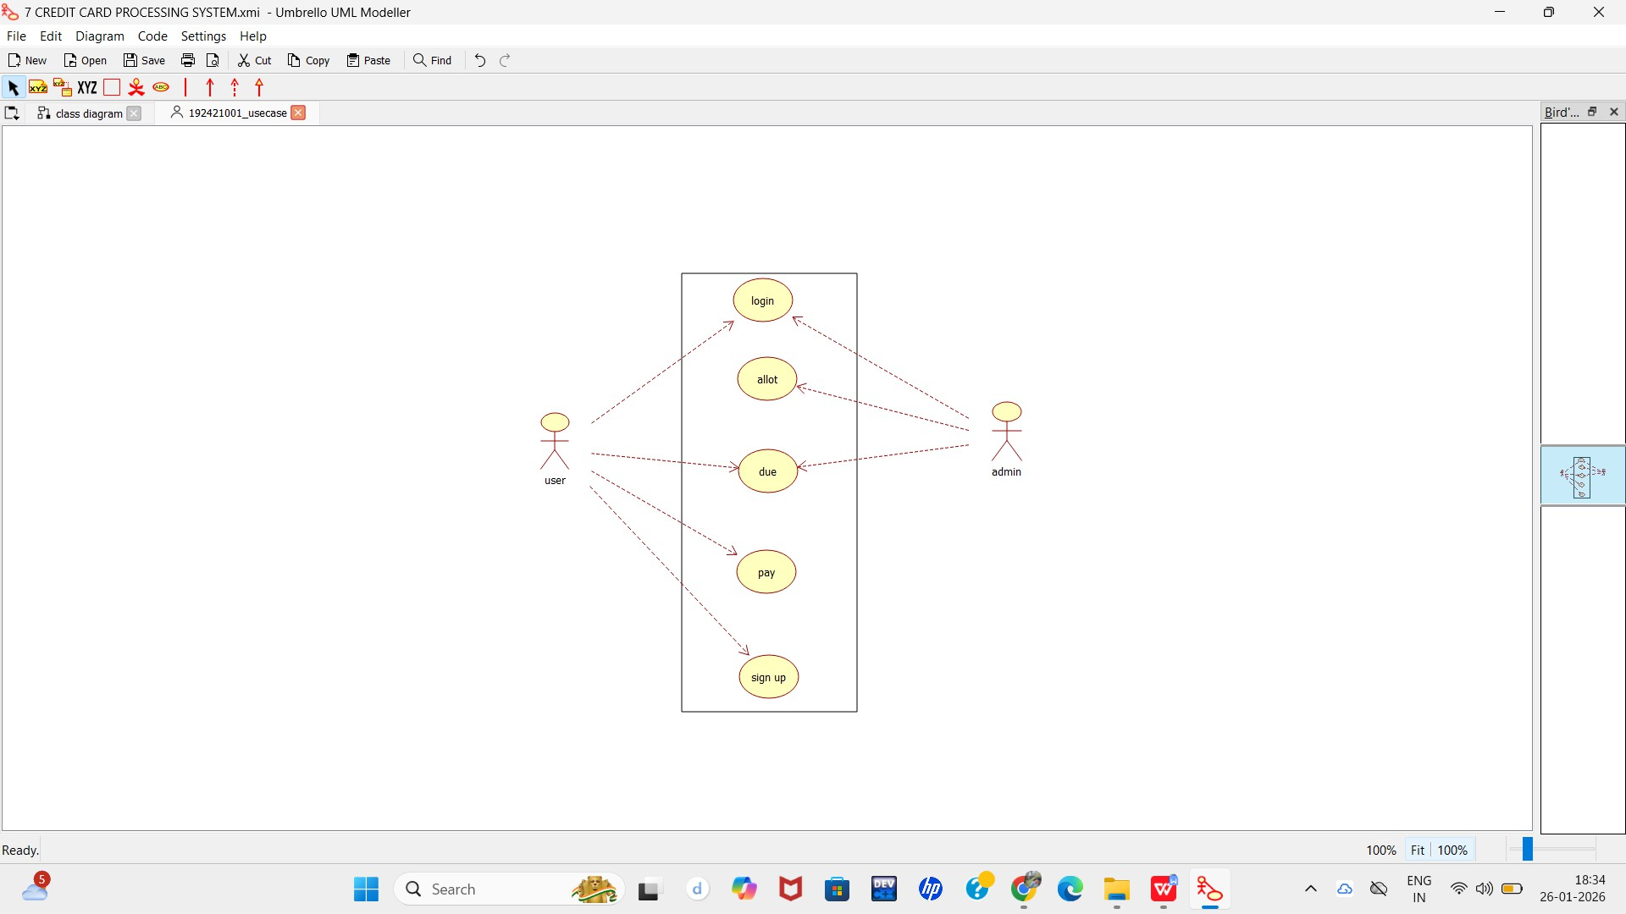

CLASS DIAGRAM:

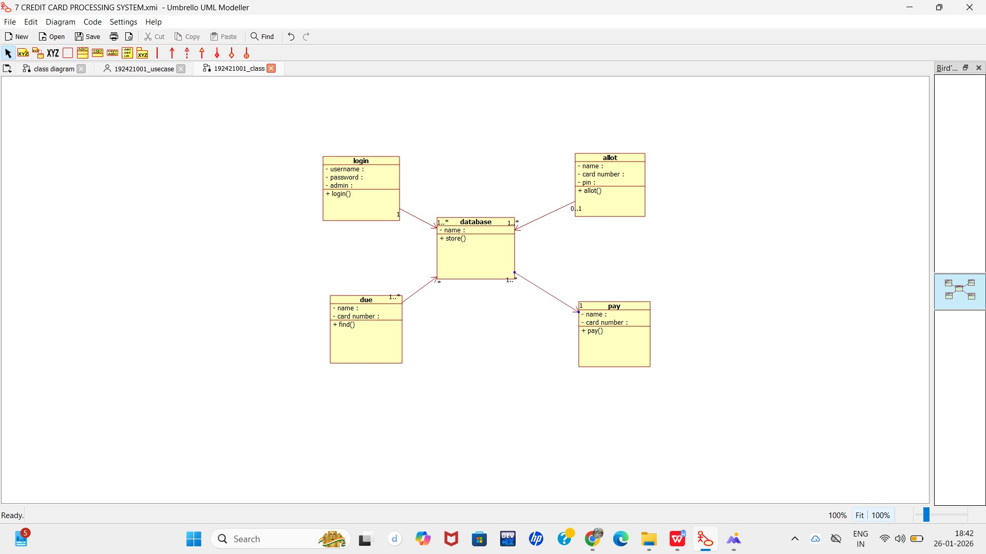

ACTIVITY DIAGRAM:

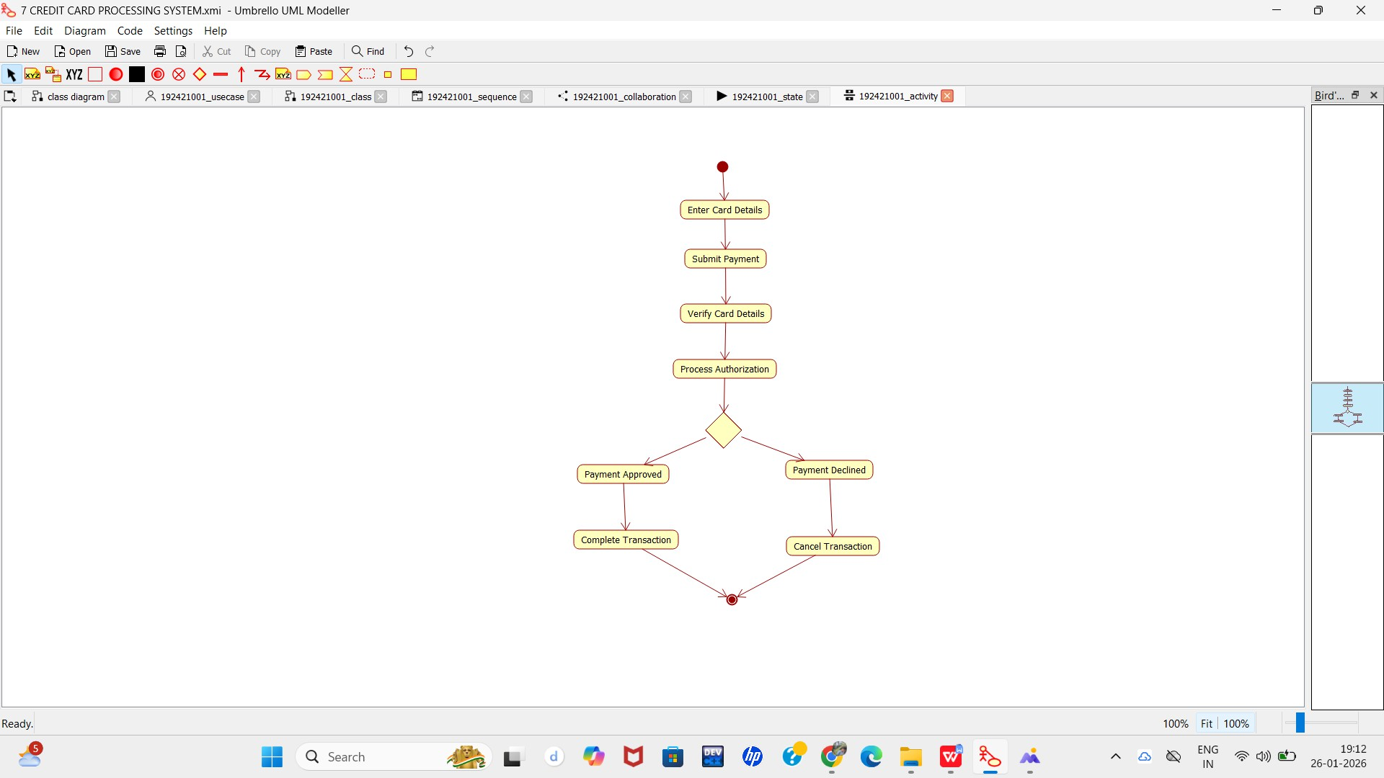

SEQUENCE DIAGRAM:

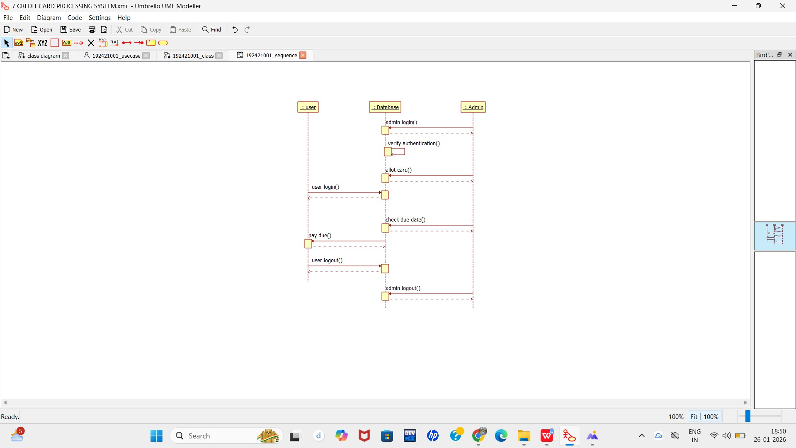

COLLABORATION DIAGRAM:

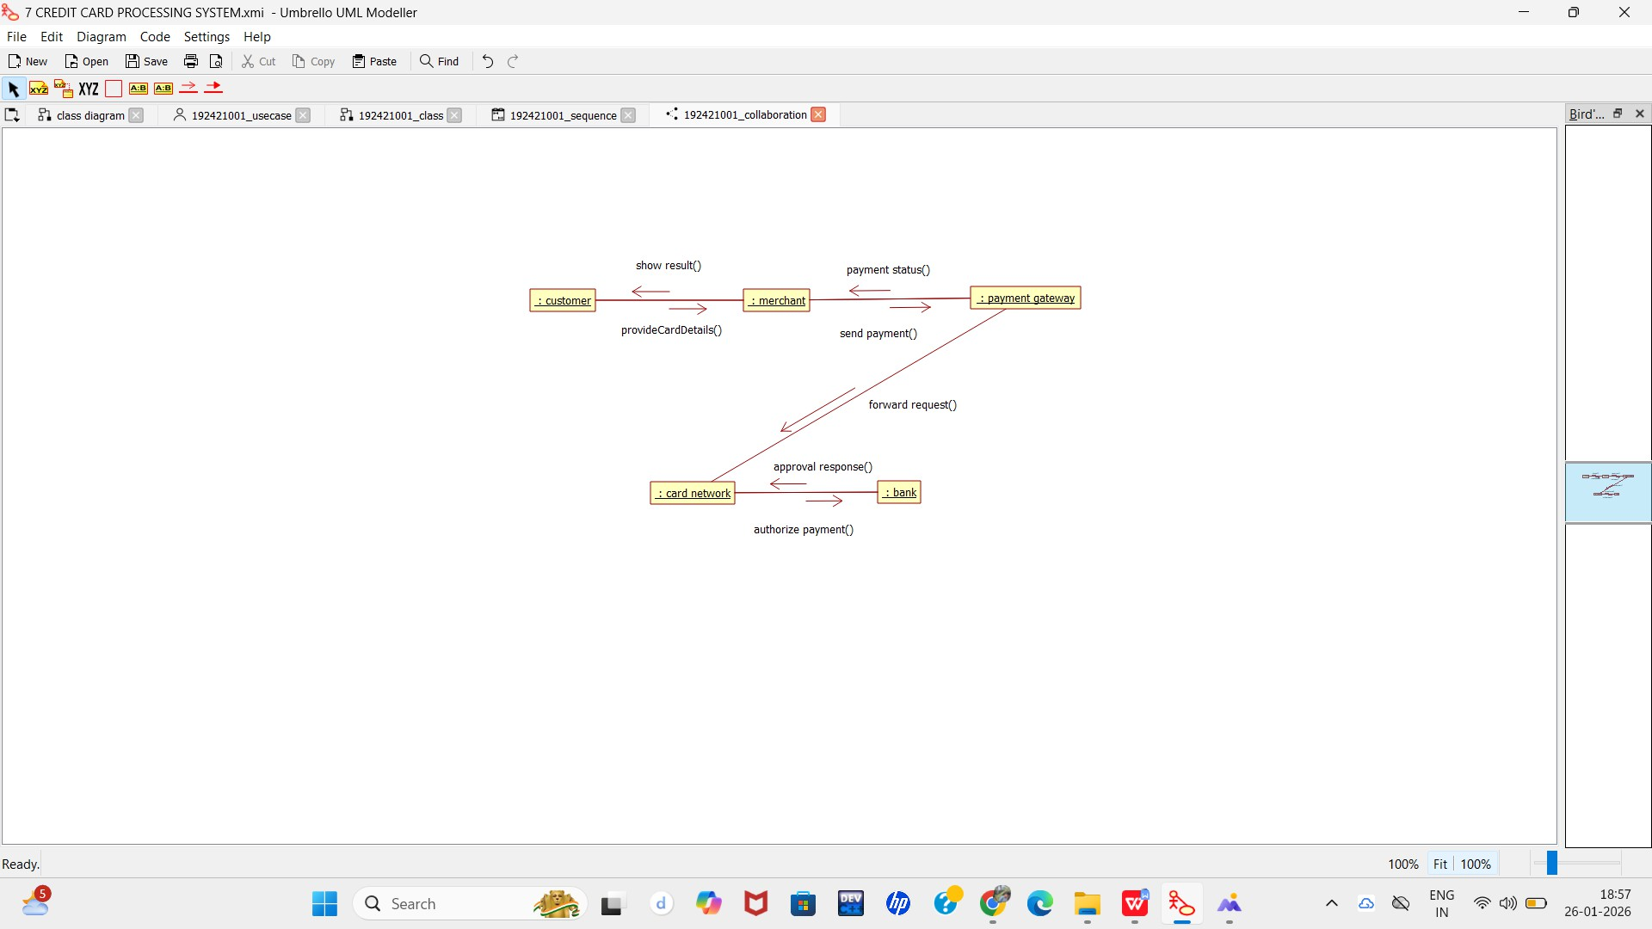

STATE CHART DIAGRAM:

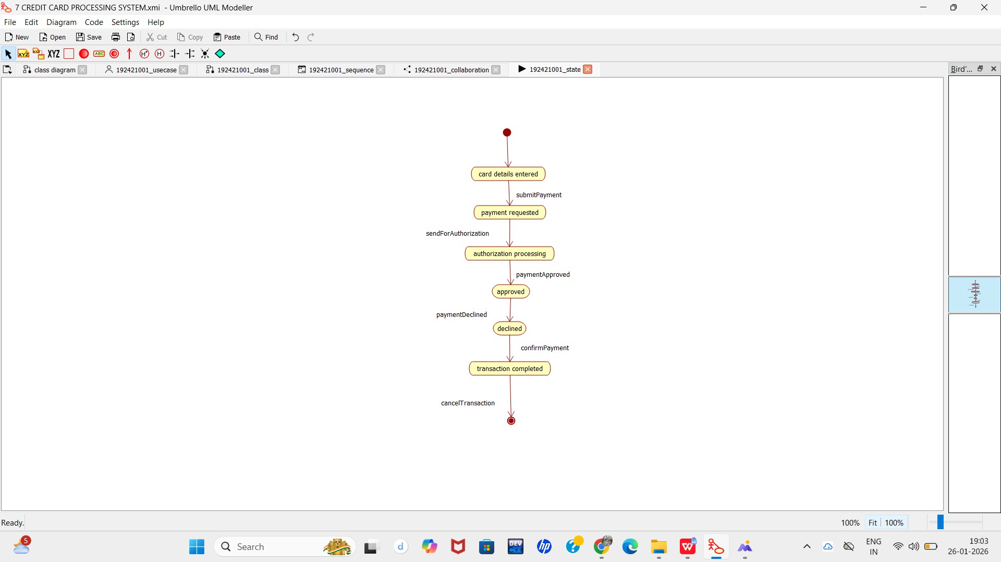

COMPONENT DIAGRAM:

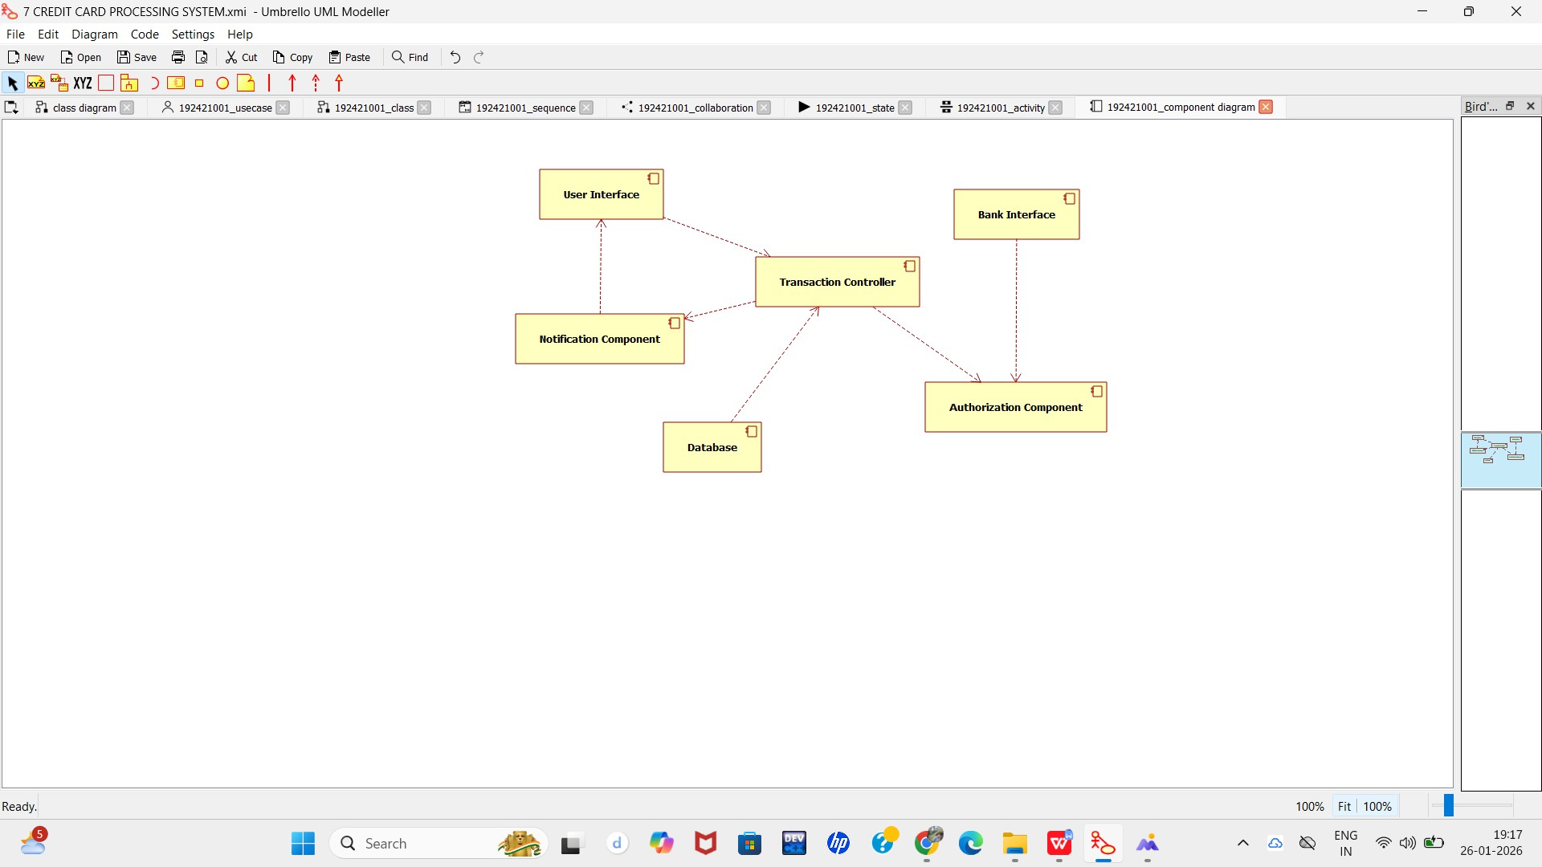

DEPLOYMENT DIAGRAM:

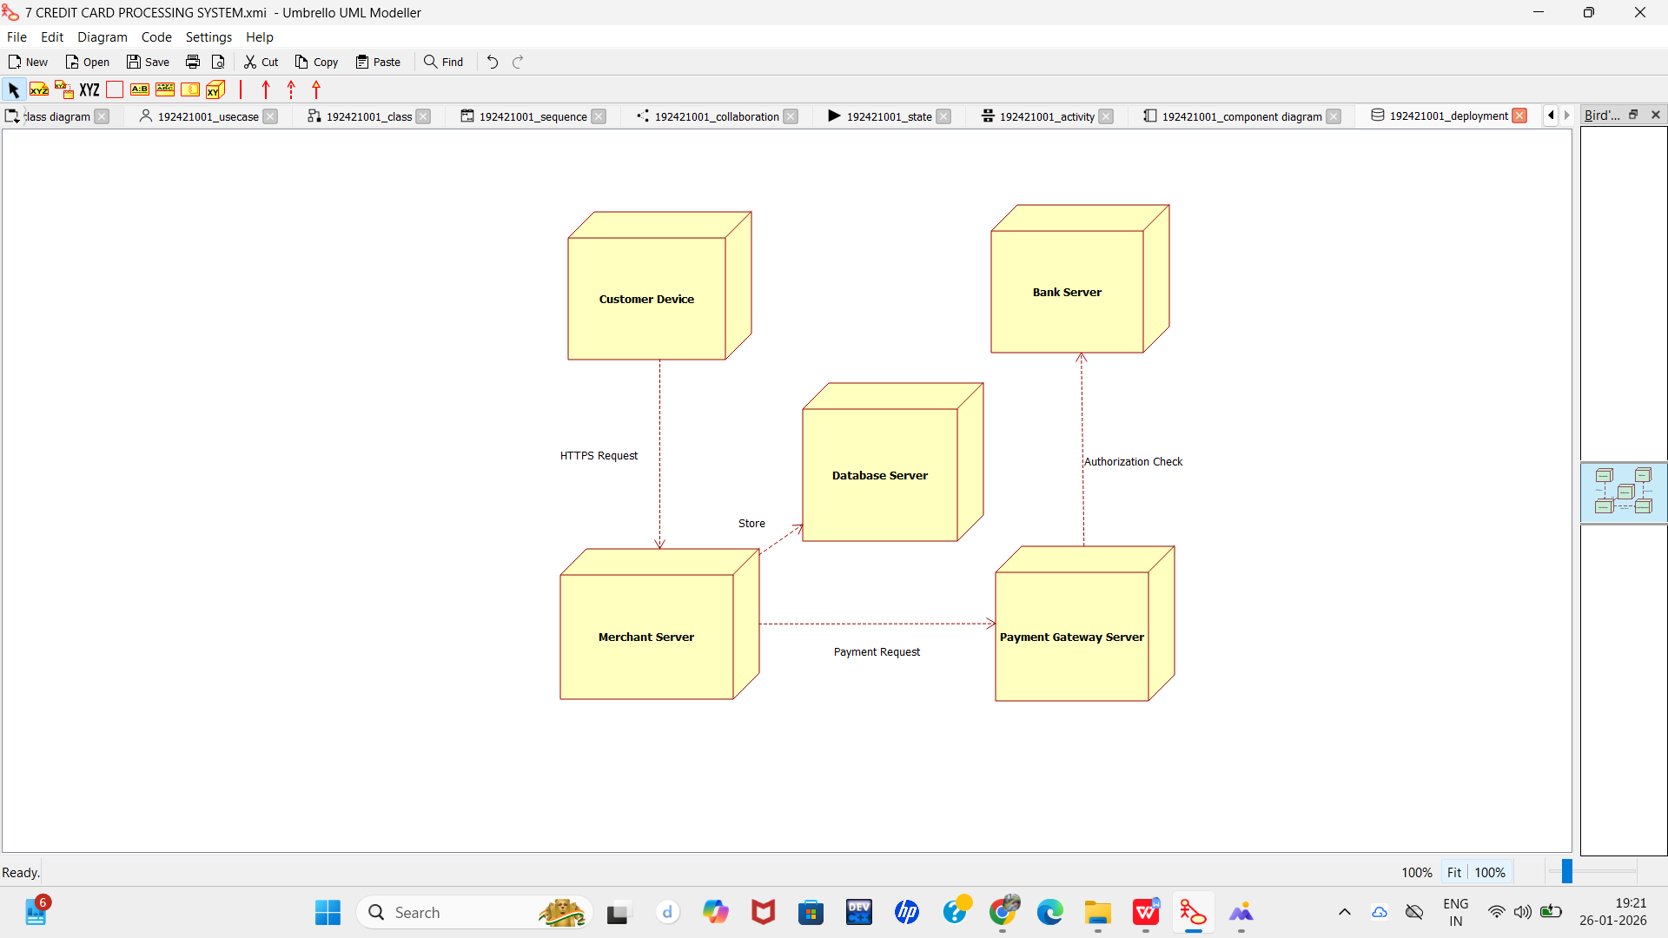

PACKAGE DIAGRAM:

